Use-Case Realization Report
Add Fap

Issue <1.0>
Revision History
Date | Issue | Description | Author
<02/08/09> | <1.0> | <Add FAP> | <Karen Gao>

Table of Contents
1. Brief Description 4
2. Flow of Events 4
2.1 Standard Flow 4
2.2 Exceptions 4
3. Interaction Diagrams 5
3.1 Colloboration Diagram for Add Fap 5
4. Participating Objects 5
5. Class Diagrams 6
5.1 Class Diagram for Add Fap 6
6. Derived Requirements 6

Use-Case Realization Report
Add Fap

Brief Description
This is the addition of the FAP by the Portal Administrator. It shall check for duplicate entry before adding the FAP.

Flow of Events

Standard Flow
This use case covers the events of adding FAP, which is part of the customer maintenance package. The standard flow of events is described as below:
- The Portal Administrator shall press the button to send out a command of “AddButtonClicked” on the interface of MaintainFapPage.
- The operation checkFap will check for the duplication of entries in the FapController.
- Then the operation getFunctionDataList shall get function data list from FunctionData object.
- Subsequently the FapController shall assign the new FAP to the FAP object and display the FAP list on the MaintainFapPage through the operation showFapList.

Exceptions

- If the duplication of entry found, a message will be sent to the MaintainFapPage through the operation showFapDuplicated.

Interaction Diagrams

Colloboration Diagram for Add Fap
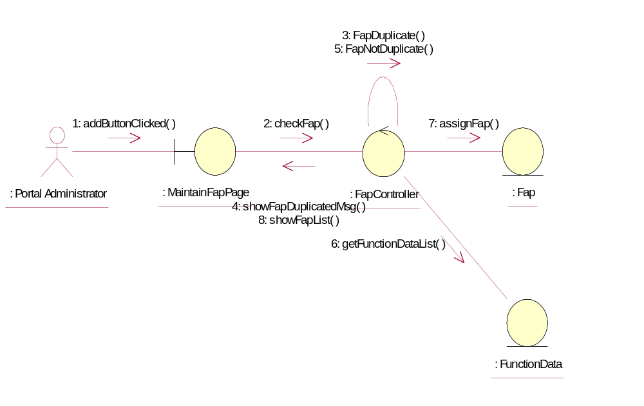

Participating Objects
: Fap
This Entity is Fap object

: FapController
This is controller to add, delete, update of Fap

: FunctionData
This Entity is FunctionData object

: MaintainFapPage
This is a page for adding, deleting, updating of Fap

: Portal Administrator
This is super user in this system

Class Diagrams

Class Diagram for Add Fap
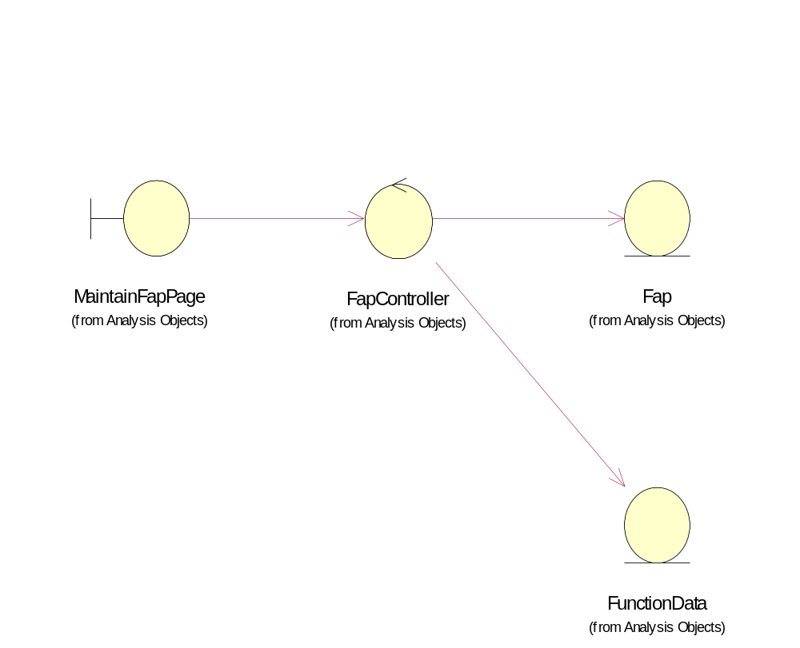

Derived Requirements
Only Portal Administrator has rights to access this page.

